BLOG PLATFORM
@CREATIVITY THINK (9483175986/7019689991)

ABSTRACT:
The Blog Platform is a full-featured content management and publishing system designed for writers, educators, news portals, and personal portfolio creators. The system allows users to write, edit, and publish blog posts with support for categories, tags, comments, scheduling, SEO tools, and a dedicated analytics dashboard. The platform includes two major roles: User and Admin. Users can create and manage their own content, while administrators moderate posts, manage categories, handle SEO configurations, and review platform-wide analytics. Built using Django with Django Rest Framework on the backend and React on the frontend, the system offers a fast, secure, and scalable architecture suitable for modern content delivery..

INTRODUCTION OF THE PROJECT:
The rise of digital content creation has increased the demand for efficient and feature-rich blogging platforms. Traditional blogging systems often lack essential tools such as SEO analytics, scheduled publishing, content moderation, and structured categorization. The Blog Platform introduced here solves these challenges through a dynamic, modern, and API-driven architecture. The backend enforces robust content logic, while the React frontend ensures a responsive and interactive user experience. The platform helps individuals and organizations publish high-quality content efficiently without requiring technical expertise..

PROJECT OBJECTIVES:

• Provide a structured blog creation and publishing environment.
• Enable users to write, edit, save drafts, and publish articles easily.
• Support categories, tags, comments, and SEO optimization tools.
• Offer scheduling features for automated post publishing.
• Provide an analytics dashboard for user and admin insights.
• Allow administrators to moderate posts and manage user-generated content.

PROBLEM OF THE STATEMENT:
Existing blogging platforms often lack personalized control, efficient moderation tools, and modern content management workflows. Many creators struggle with organizing posts, tracking engagement, and optimizing for search engines. Additionally, admin teams often require structured moderation tools to ensure quality and compliance. The Blog Platform resolves these limitations by providing a robust system with automated scheduling, SEO utilities, analytics, and moderation dashboards, ensuring a seamless publishing experience for all stakeholders..

MOTIVATION OF THE PROJECT:
• To simplify content creation for writers and individuals without technical skills.
• To provide a centralized and structured content management system.
• To reduce the dependency on manually maintaining blog content.
• To introduce essential blogging tools like SEO checks and analytics.

BLOCK DAIGRAM OF PROJECT:

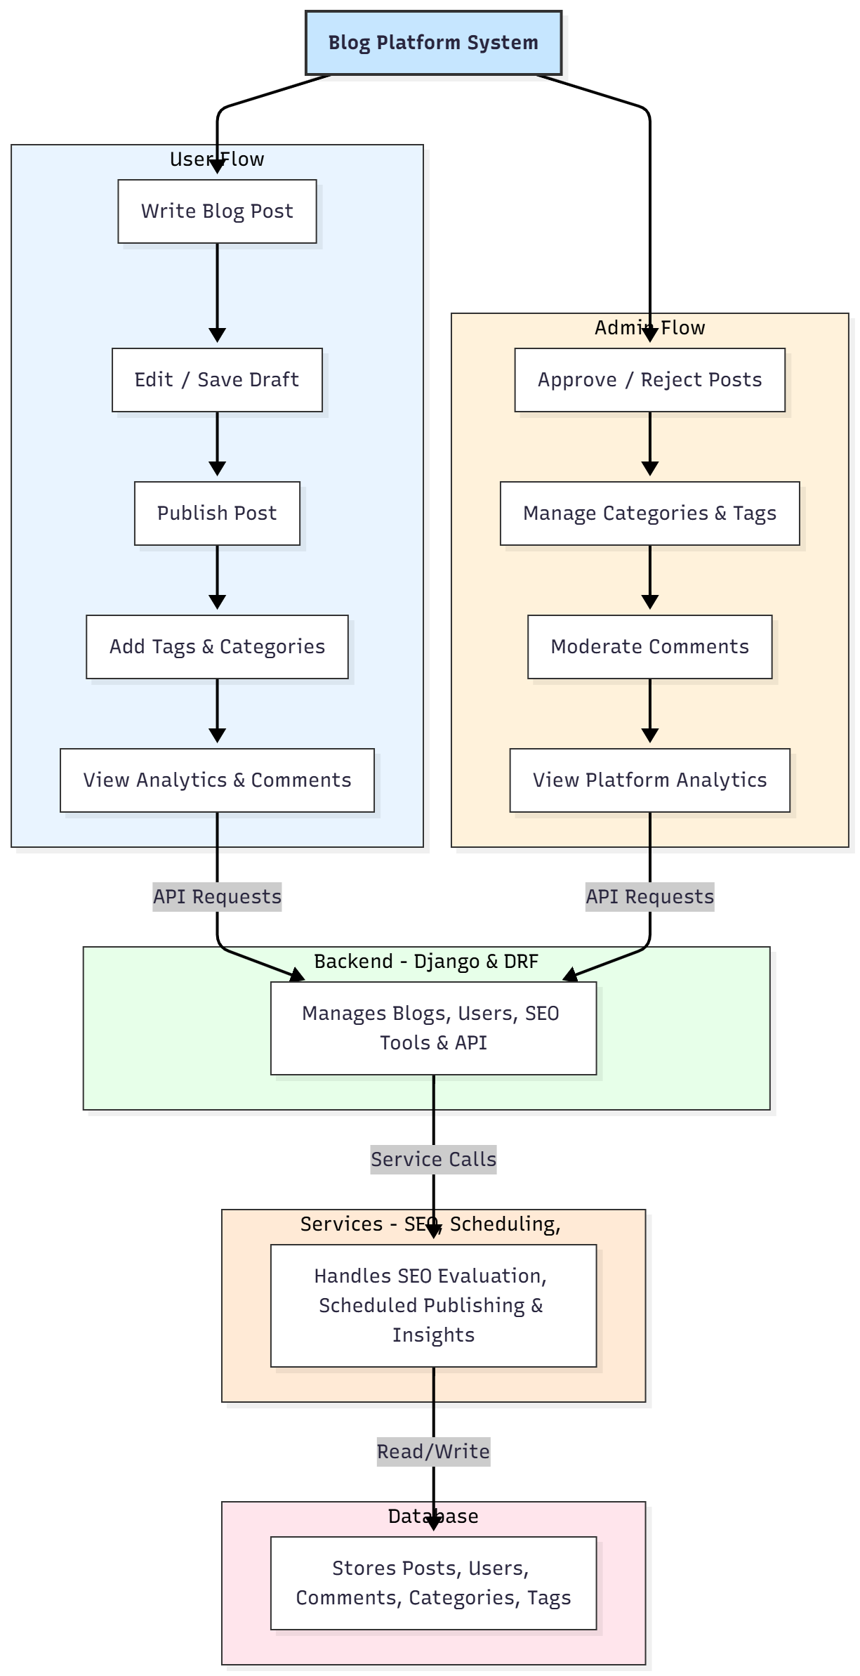

WORKING OF THE PROJECT:
The system begins with the user registering or logging into the platform. Once authenticated, users can write blog posts, save drafts, add tags/categories, and publish their content. The backend ensures validation, SEO score evaluation, and scheduled publishing for posts set to go live at a future date. Users can interact with comments and view basic analytics like post views and engagement metrics. Administrators manage all content by approving or rejecting posts, organizing categories, moderating comments, and reviewing platform-level analytics. All data is processed through Django APIs and stored in the SQL database, ensuring speed, security, and reliability..

SOFTWARE REQUIREMENT:
- Backend:
  - Python 3.x
  - Django
  - Django REST Framework
  - SQLite/PostgreSQL
- Frontend:
  - Node.js and npm
  - React.js
  - Axios
- Development Tools:
  - Visual Studio Code
  - Postman (for testing APIs)
  - Git/GitHub (for version control)
- Server/Deployment (Optional):
  - Gunicorn, Nginx, or Heroku/AWS for hosting

ADVANTAGES OF THE PROJECT:

• Modern and user-friendly blog creation interface.
• Automated scheduled publishing.
• In-depth SEO support and analytics.
• Comment moderation for clean and safe content.
• Scalable admin dashboard for content oversight.
• Secure REST API architecture.
• Real-time analytics for users and admins.
• Great for professional portfolios and news publishing.

APPLICATIONS OF THE PROJECT:
• Blogging websites
• Online magazines
• Personal portfolio websites
• Educational institutions
• News and media platforms

REFERENCES:

- Django REST Framework Documentation — Django Software Foundation. Django Documentation. Available: https://docs.djangoproject.com/
- Django REST Framework. DRF Documentation. Available: https://www.django-rest-framework.org/
- React. React Official Documentation. Available: https://reactjs.org/docs/getting-started.html
- Redux. Redux Documentation. Available: https://redux.js.org/introduction/getting-started
- PostgreSQL Global Development Group. PostgreSQL Documentation. Available: https://www.postgresql.org/docs/
- MySQL. MySQL Reference Manual. Available: https://dev.mysql.com/doc/
- Git. Git Documentation. Available: https://git-scm.com/doc
- Node.js. Node.js Documentation. Available: https://nodejs.org/en/docs/
- Axios. Axios Documentation. Available: https://axios-http.com/docs/intro
- Socket.io Documentation – https://socket.io/docs/

